
TOBB ETU
Economy & Technology University
BIL 495 / YAP 495

Software Design Description (SDD)
Reference: IEEE 1016-2009

Document Control Table
Document Title | Project Closure Report
Document ID | SDD1
Prepared By (Author) | FinalStack
Reviewed By
Approved By
Preparation Date | 19-11-25
Approval Date
Version / Revision | 1.0
Confidentiality Level | Internal / Restricted / Public
Reference Standards | IEEE 15288, IEEE 12207, INCOSE SE Handbook v5

Change Record (Revision History Table)
Revision | Date | Prepared By | Reviewed/Approved By | Description of Change
1.0 | 19-11-25 | FinalStack |  | Initial Release

1. Introduction
1.1 Purpose
1.2 Scope
1.3 References
2. System Overview
2.1 System Architecture
2.2 Design Rationale
3. Detailed Design
3.1 Component Descriptions
3.2 Interface Descriptions
3.3 Data Design
3.4 Algorithm Design
4. Traceability

1. Introduction

1.1 Purpose
This Software Design Document (SDD) describes the detailed design of the AI-Enhanced Data Preprocessing and Ingestion Layer.
It expands the system-level requirements defined in the Software Requirements Specification (SRS) and the high-level structure defined in the Software Architecture Document (SAD).
This document focuses on module-level design, component interactions, data structures, algorithms, and internal interfaces.

1.2 Scope
This SDD covers:
- Data Ingestion Layer
- Preprocessing Layer
- Event Bus / Messaging Layer
- HL7 Communication Layer
- AI Integration Layer
- Web Dashboard and Configuration Layer
- Audit/Logging Layer (without internal DB — logs are sent to hospital audit backend)
Out of scope:
- Hospital databases
- AI model training or inference engine implementation (only integration)
- Long-term data storage
Subsystems not in scope:
- AI model training logic
- External hospital systems
- Vendor-specific hardware programming SDKs

1.3 References
SRS SRS v1.2.docx 19-11-25
SAD SAD v1.0.docx 19-11-25
HL7 v2/v3 Standards
FHIR R4 Specification
DICOM Standard

2. System Overview

2.1 System Architecture
The system uses a Layered Architecture combined with Event-Driven Architecture.
Layers:
- Device Integration Layer
  - Accepts raw, HL7, or DICOM streams from NICU devices
- Event Bus (Core)
  - Publishes internal events:
RawDataReceived, DeviceConfigUpdated, PreprocessingCompleted, AIRequestCreated, etc.
- Preprocessing Layer
  - Cleans data
  - Handles missing values
  - Performs filtering, noise reduction
  - Generates datasets for AI training
- AI Integration Layer
  - Sends processed data to AI engine
  - Receives diagnostic results
- HL7 Communication Layer
  - Sends HL7 messages to the hospital system
  - Receives HL7 device input (if device speaks HL7)
- Configuration & Dashboard Layer
  - Web dashboard for device configuration
  - Preprocessing rule configuration
  - Audit log viewer (logs retrieved from hospital system)
See SAD section 2 and section 3 for diagrams and deployment details. Data flow, component and class diagrams can be found on Appendix

2.2 Design Rationale
- Layered architecture ensures modularity and separation of concerns. Preprocessing, AI communication, and device integration are isolated.
- Event-driven design ensures scalability and asynchronous processing (device streams → preprocessing → AI → hospital system).
- HL7 standardization ensures interoperability with existing hospital systems.
- No local database reduces security risk — all persistence/audit is delegated to hospital infrastructure.
- Web dashboard centralizes configuration without storing patient data locally.

3. Detailed Design

3.1 Component Descriptions

1. Device Input Adapter
- Connects to NICU devices (serial, TCP/IP, HL7 feed, DICOM PACS).
- Converts raw input into internal canonical format.

2. Event Bus
- Internal publish/subscribe mechanism.
- Used to decouple components.

3. Preprocessing Engine
- Applies transformations:
  - Missing value handling
  - Signal smoothing
  - Noise filtering
  - Normalization
- Generates dataset chunks for training/evaluation.
- Logs all steps to hospital audit backend.

4. AI Integration Component
- Sends preprocessed data to AI Diagnosis Engine.
- Receives inference results.
- Transforms results to HL7 standard format.

5. HL7 Communication Layer
- Converts incoming/outgoing messages into HL7 v2/v3.
- Sends results to hospital EMR/EHR system.
- Implements ADT, ORU, or custom message types.

6. Configuration & Dashboard
- Allows:
  - Device registration
  - Preprocessing configuration
  - HL7 routing configuration
- Only stores metadata and settings provided by hospital system.

7. Audit & Logging Layer
- Generates structured logs.
- Sends logs to hospital audit system using:
  - syslog
  - FHIR
  - HL7 ACK messages (if required)

3.2 Interface Descriptions

HL7 Interfaces
- Input: HL7/DICOM messages from devices
- Output: HL7/DICOM messages to hospital system

AI Engine Interface
- Protocol: REST or gRPC
- Input: preprocessed data
- Output: diagnosis results

Dashboard Interface
- REST APIs for:
  - Device list
  - Update preprocessing rules
  - Fetch audit record.

3.3 Data Design
No internal database. Only transient runtime structures. All persistence is external (hospital systems/databases). Passing data will be in HL7 standards.

3.4 Algorithm Design

Preprocessing Algorithm (High Level)
function preprocess(rawEvent):
data = extract(rawEvent.payload)
if missing_values(data):
data = fill_missing(data)
data = filter_noise(data)
data = normalize(data)
return PreprocessingCompletedEvent(data, steps)

4. Traceability
Design-Traceability matrix can be found in appendix

5. Appendix
- Design-Traceability v1.0 19-11-25

Data Flow Diagram
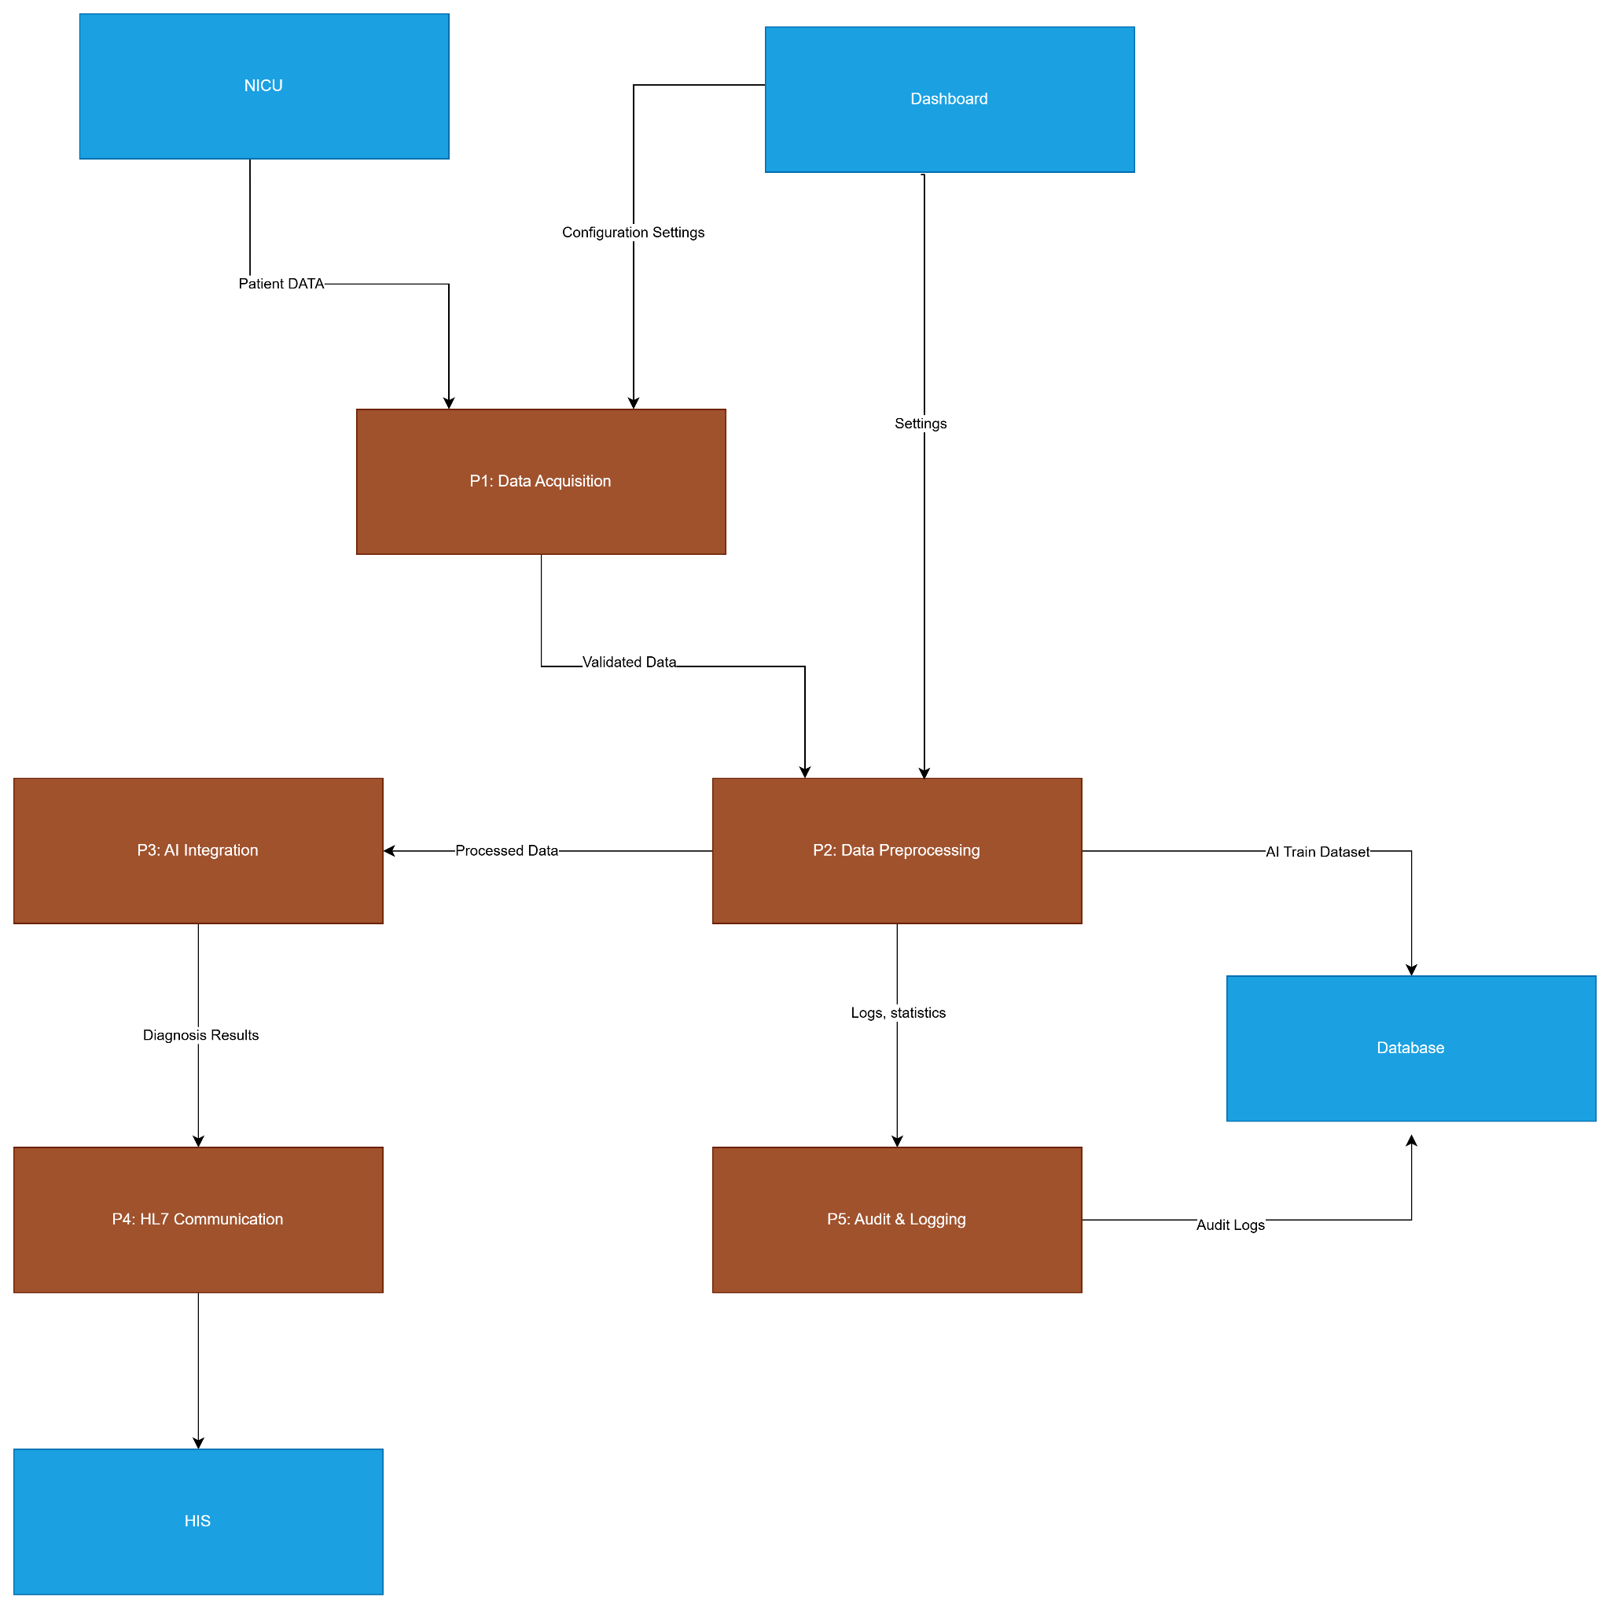

Component Diagram
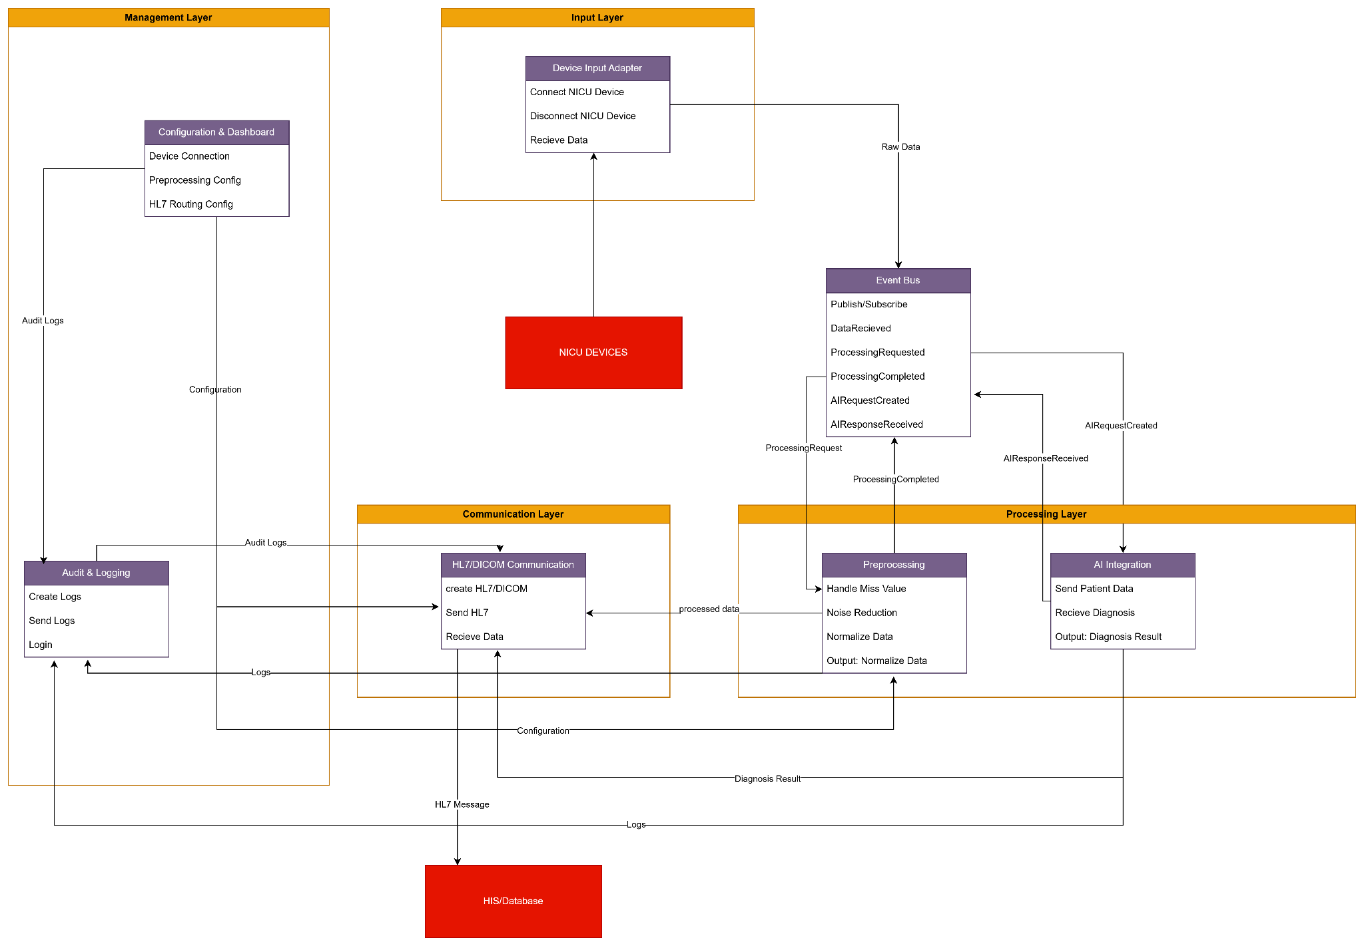

Class Diagram
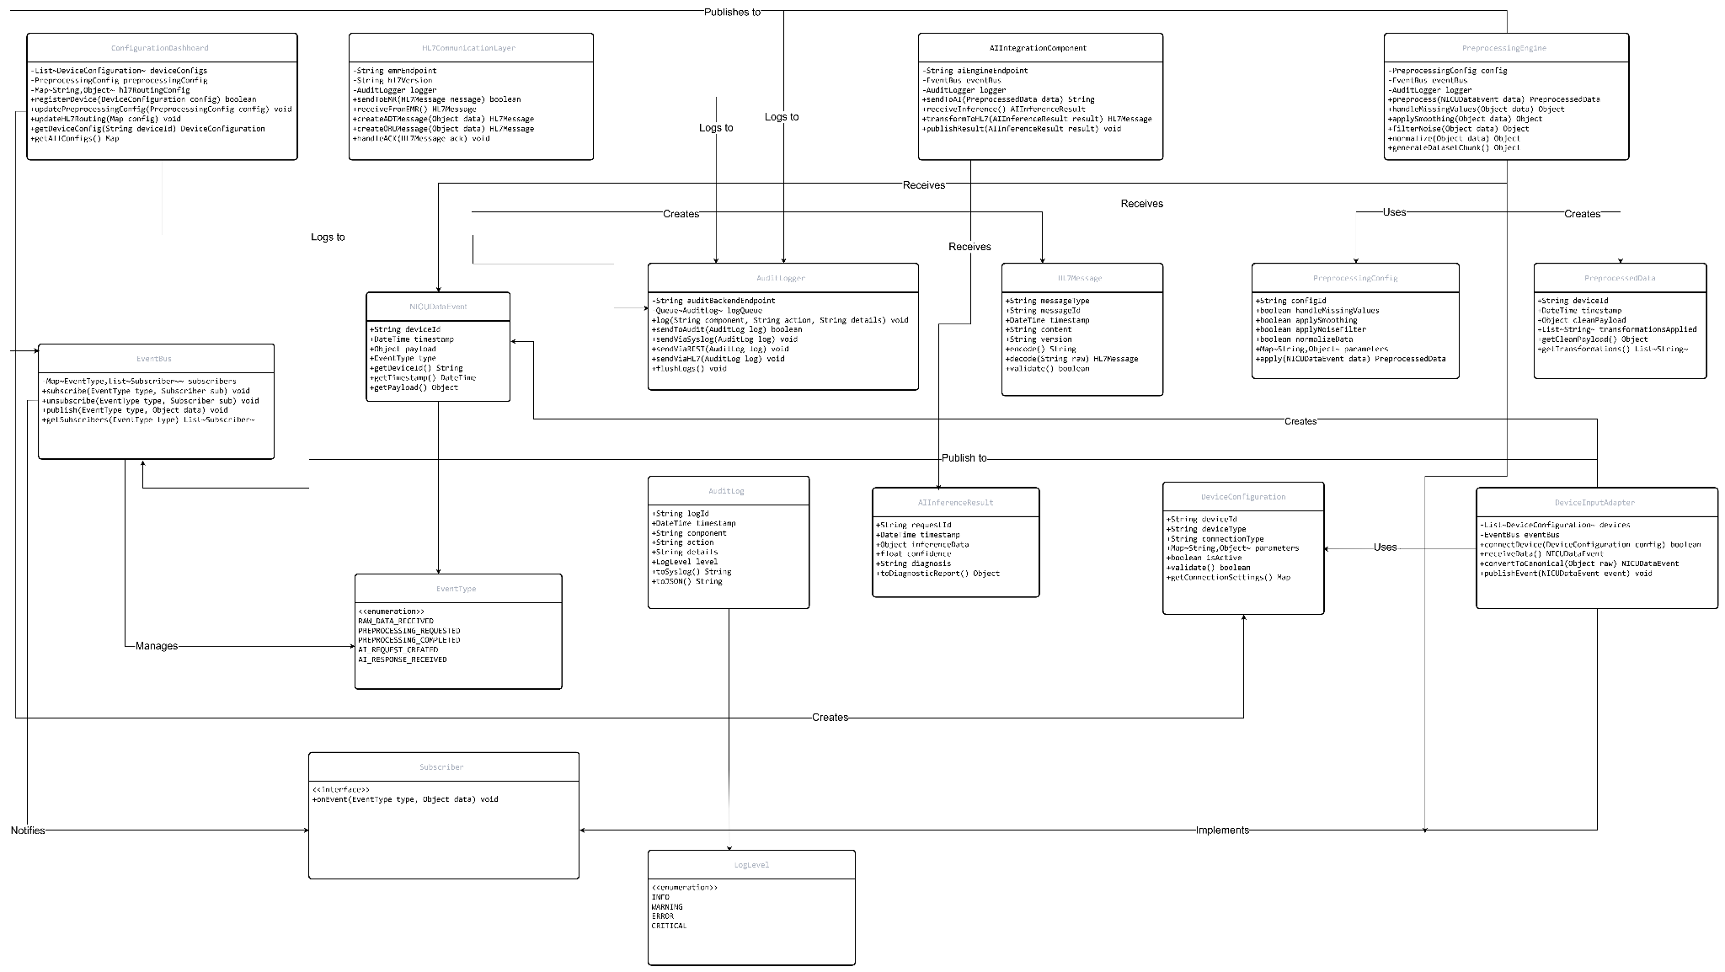

6. References
- HL7 v2.8 Standards
- DICOM Standard
- SAD v1.0.docx 19-11-25
- SRS v1.2.docx 19-11-25

